2025 Grande Promenade
June 20-22, 2025 In El Paso, Texas

Hotel Reservations
Candlewood Suites
4631 Cohen Ave
El Paso, Texas 79924
Phone: (915) 755-9000
Group Rate: $110 per night + Tax
(Advise you are with the 40 & 8)

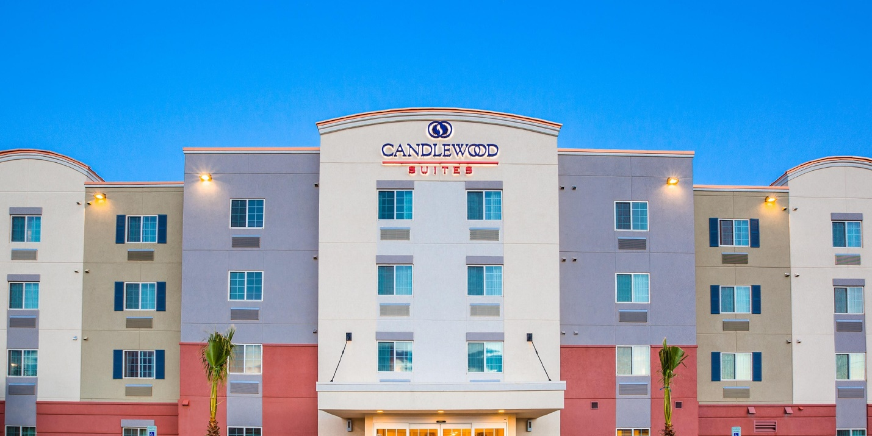
Hotel Reservation
Deadline is June 6,2025
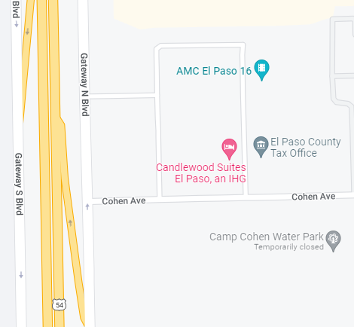
I-10W to US 54 Ft Bliss Exit # 22B
From US 54 North take Transmoutian Exit #29

